***Assignment***

**Aim:** Design and Prototype a High-Converting Landing Page for Genotek's "Expansion Joint Covers".

***Introduction:***

This project focused on developing a lead-generating landing page for the brand of Gentotek "Expansion Joint Covers." The primary goal was to create an engaging online presence that not only attracts the target audience but also encourages them to inquire about the product.

***Design Choices***:

1. **User-Friendly Interface:**
   * Implemented a straightforward navigation menu for ease of exploration.
   * Maintained a clean layout to ensure a seamless user experience.
   * Prioritized intuitive design elements for effortless navigation.

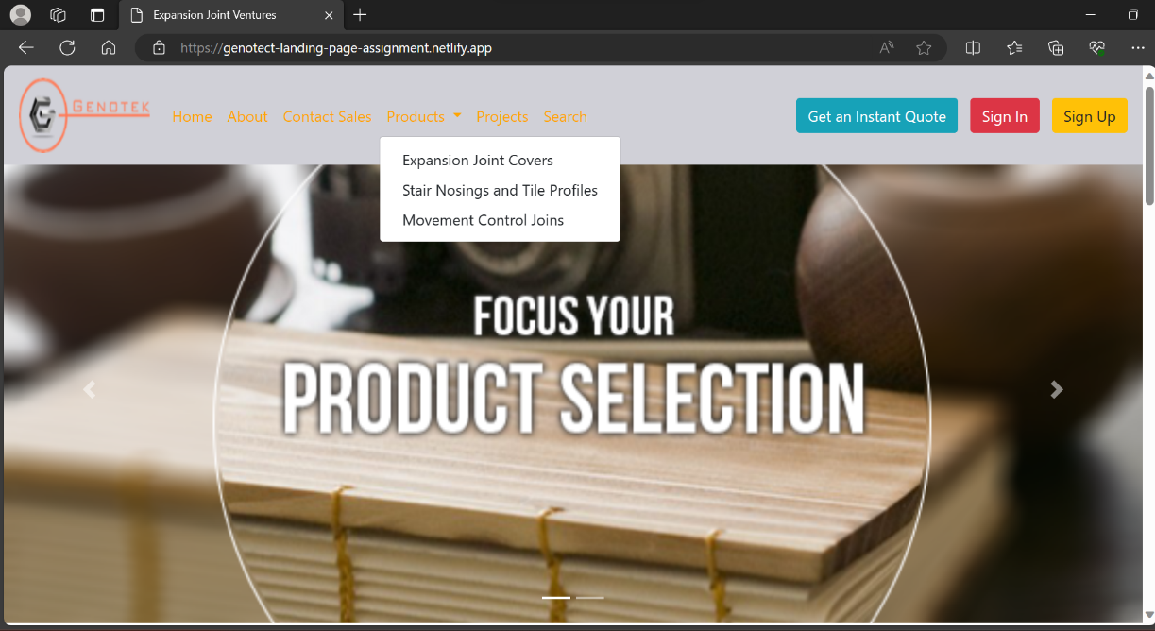

***Fig 1: Navigation Bar For Easier Exploration***

1. **Quirky and Creative Elements:**
   * Incorporated vibrant color schemes aligned with the branding.
   * Utilized playful graphics illustrating the versatility of Expansion Joint Covers.
   * Added quirky design touches to enhance brand memorability.

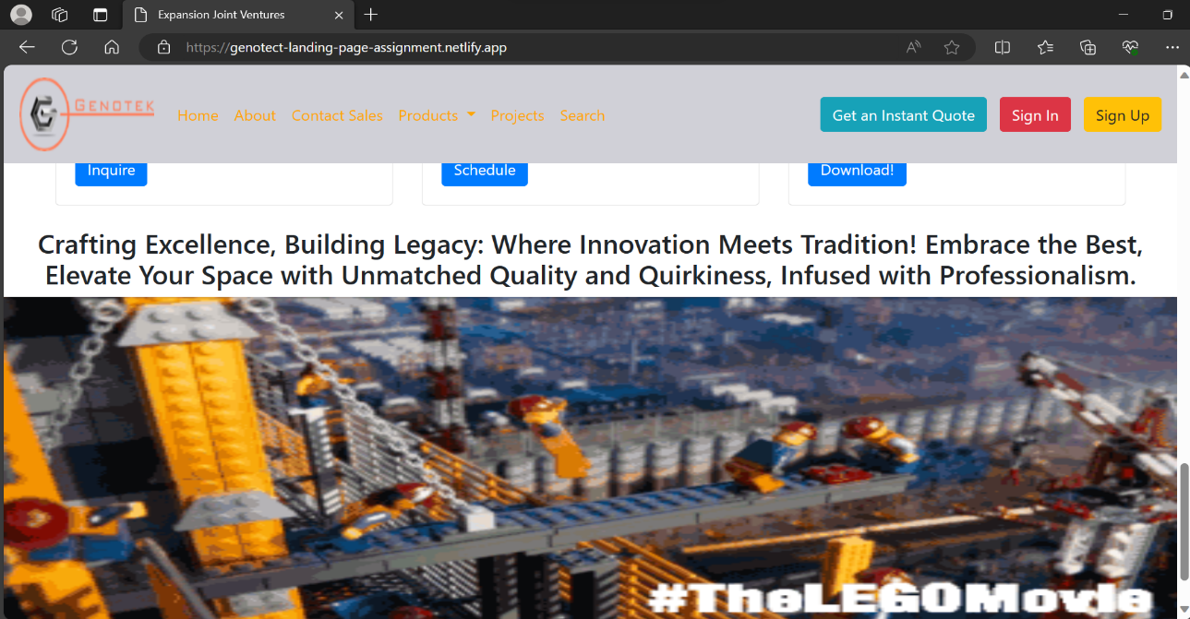

***Fig 2: Graphics for Memorability***

1. **Engaging Content:**
   * Crafted compelling headlines and concise product descriptions.
   * Placed strategic calls-to-action to guide users through the sales funnel.

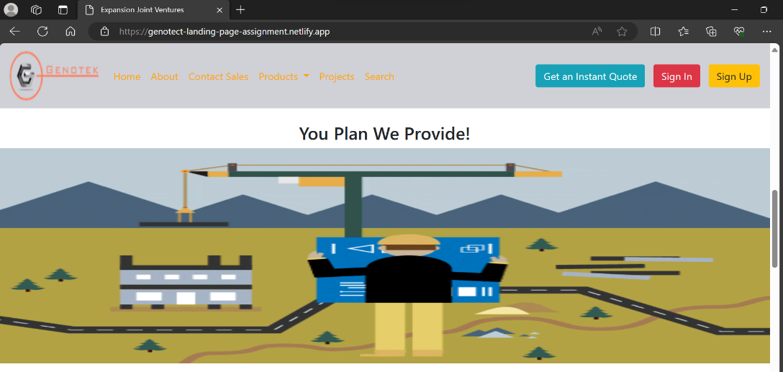

***Fig 3: Graphics and Taglines***

1. **Lead-Generating Features:**
   * Strategically positioned contact forms for easy user inquiries.
   * Implemented clear and compelling calls-to-action to drive user interaction.

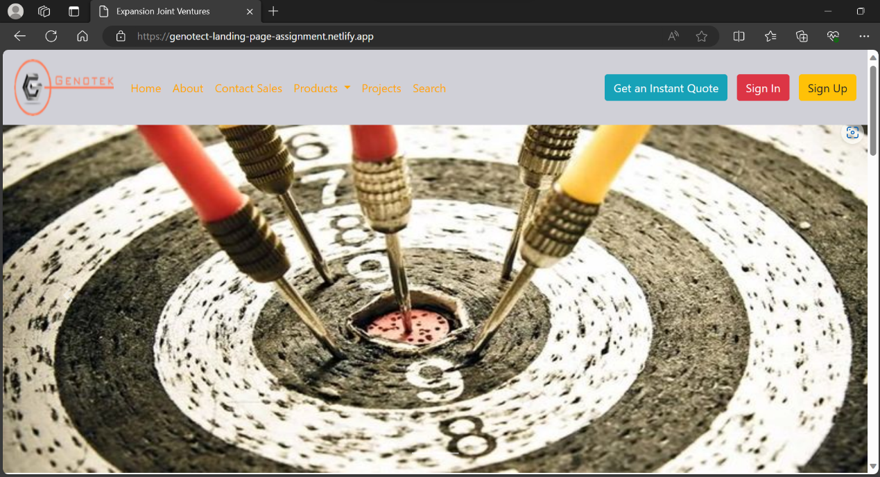

***Fig 4: Contact on top and buttons for authentication***

1. **Responsive Design:**
   * Ensured a responsive design for seamless viewing on various devices.
   * Prioritized consistency in visual appeal across desktop, tablet, and mobile platforms.
   * Ensured the landing page adheres to web accessibility standards, making it usable for individuals with disabilities.
   * Implemented alternative text for images, provided sufficient color contrast, and ensured keyboard navigation compatibility for a more inclusive user experience.
   * The Clear Call-to-Action(CTA) prompts users to take specific actions, such as submitting an inquiry or exploring product details, contributing to higher conversion rates.

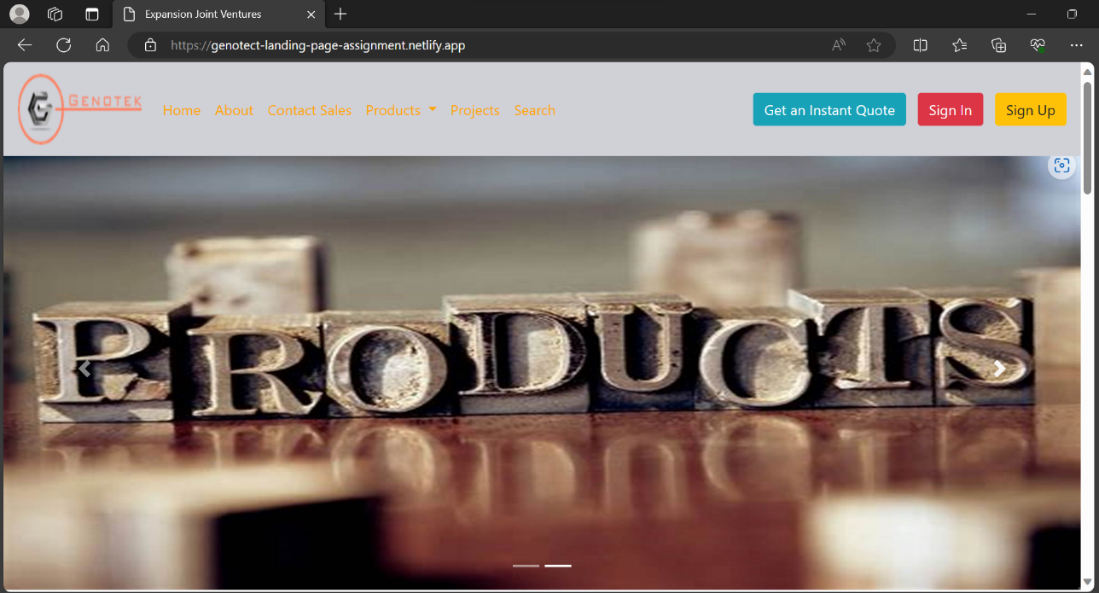

***Fig 5: Website in Laptop***

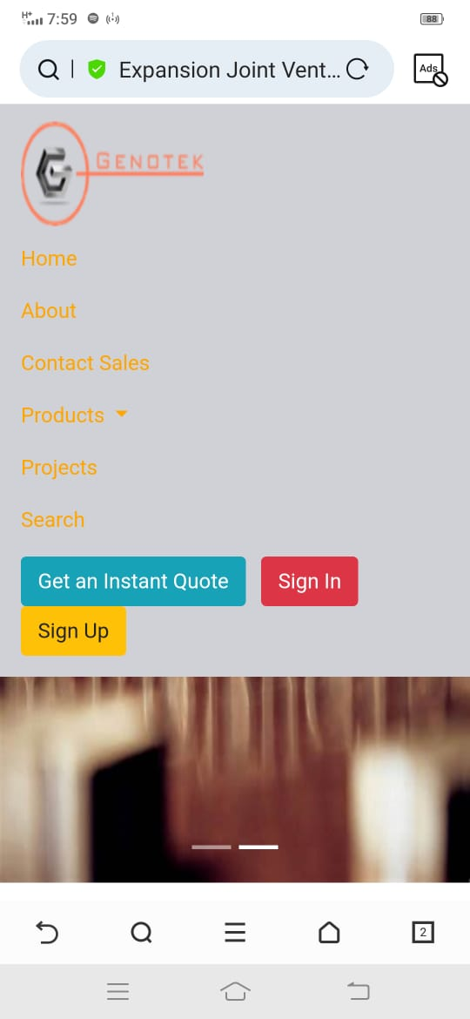

***Fig 6: Website in Mobile Phone***

1. **SEO Optimization:**

* Conducted keyword research for "Expansion Joint Covers" to enhance discoverability.
* Integrated researched keywords into content and headers for improved search engine rankings.

***Fig 7: 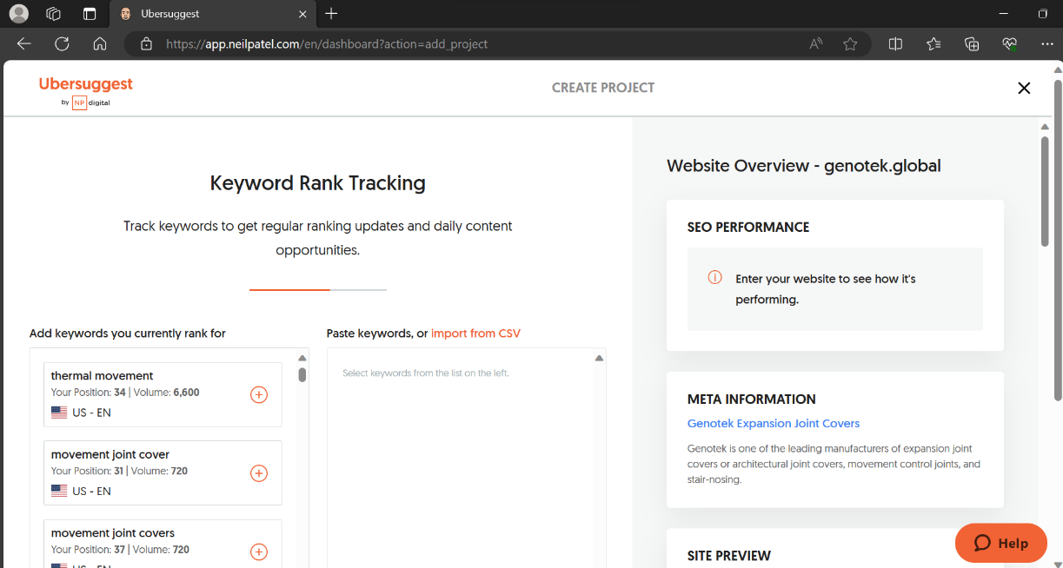Seeing Website traffic and keywords***

1. **GitHub Repository and Deployment:**
   * Created a GitHub repository to track and manage the project's source code and design files.
   * Utilized version control to facilitate collaboration and future updates.
   * Deployed the landing page to a web hosting service for public access.

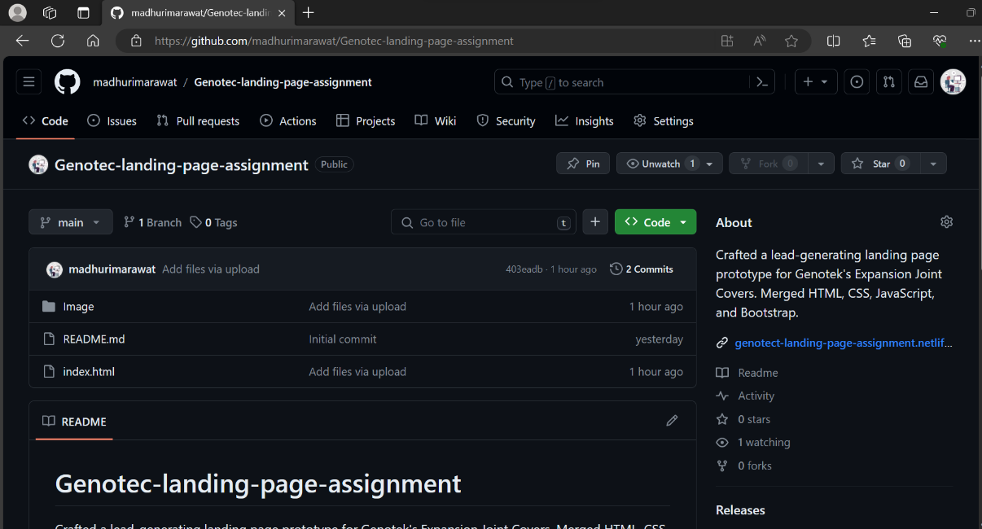

***Fig 8: GitHub Repository***

1. **Prototype:**

* Developed a prototype showcasing the designed landing page, including visual representations of the layout, graphics, and interactive elements.
* Ensured functionality and responsiveness across desktop and mobile platforms.

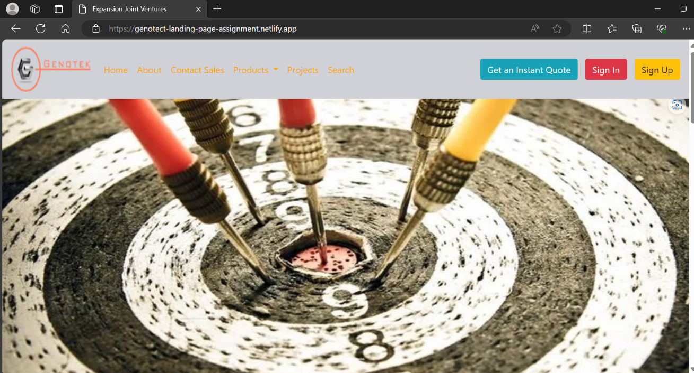

***Fig 9: Deployed Functional Prototype***

***Challenges Faced:***

* Addressed challenges related to graphic integration and ensuring a balance between creativity and information conveyance.
* Adapted design elements to maintain a cohesive look on various screen sizes.

***Conclusion:***

* This project successfully delivered a user-friendly and quirky landing page for my "Expansion Joint Covers," aligning with the brand's identity.
* The thoughtful incorporation of design choices and lead-generating features positions the landing page to effectively capture the attention of the target audience and encourage meaningful interactions.
* The deployment on a web hosting service and the establishment of a GitHub repository reflect my commitment to accessibility, collaboration, and future updates for my product's online presence.
* The prototype provides a visual representation of the designed landing page, showcasing its functionality and appeal.